FALMOUTH SAILING WEEK 2026
Saturday 8th to Saturday 15th August

Organising Authority: Port of Falmouth Sailing Association (PoFSA)
(Website: www.falmouthweek.co.uk/sailing-week)

SAILING INSTRUCTIONS
FOR THE
BAY FLEET
including the
Ancasta Champagne Race and Firebird Long-Distance Race
(including amendment 05 August)
PREAMBLE
These Sailing Instructions (SIs) are divided into five sections:
Section 1 applies to all racing.
Section 2 (beginning with SI 19) applies to Regatta courses for the Firebird class on all days except Wednesday 12 August.
Section 3 (beginning with SI 27) applies to the trapezoid courses on all days except Wednesday 12 August.
Section 4 (beginning with SI 34) applies to the Regatta courses for all classes except Firebirds, on all days except Wednesday 12 August.
Section 5 (beginning with SI 42) applies only to the Champagne Race and Firebird Long-Distance Race on Wednesday 12 August.

Abbreviations:
[NP] - A breach of this rule will not be grounds for protest by a boat.

SECTION 1 - ALL RACING
- RULES
  - The regatta will be governed by the rules as defined in The Racing Rules of Sailing. The following racing rules are changed:
    - RRS 37 will not apply.
    - RRS 63.5(c). Sailing instructions take precedence over the notice of race.
  - RRS 40.1 will apply to Firebird catamarans at all times while afloat without Flag Y being displayed.
  - IRC Rules 2025 Parts A, B and C will apply, except that:
    - [DP] IRC rule 21.1.5(e) is amended. The use of a spare mainsail will be allowed so long as it is carried onboard at all times while racing.
    - [DP] For the purpose of IRC rules 21.1.5 (d) and (e) this regatta is on consecutive days and the sails carried shall remain the same.
    - [DP] IRC rule 22.4.2 is changed: the number of crew shall not exceed the number printed on the certificate plus two.
  - World Sailing Offshore Special Regulations 2026 – 2028 Category 4 will apply.
- CHANGES TO THE SAILING INSTRUCTIONS
  - Any change to the sailing instructions will be posted before 0900 hrs on the day it will take effect, except that any change to the schedule of races will be posted by 2030 hrs on the day before it will take effect.
  - [NP] Oral changes on the water to these sailing instructions shall be broadcast on VHF Ch. 72. A broadcast shall be introduced as a change to a SI and shall identify the SI being changed. Failure to receive such broadcasts will not be grounds for redress. This changes RRS 61.1(a).
- COMMUNICATIONS WITH COMPETITORS
  - Notices to competitors will be posted to the fleet WhatsApp group. WhatsApp will also be used to make other official and courtesy communications.
  - There will not be a permanent race office. Assistance may be obtained via the helpline (07555 574308) or email (raceoffice@falmouthsailingweek.org) between 0800 and 2000.
  - On the water, the race committee intends to monitor and communicate with competitors on VHF radio channel 72. This will include general information relating to the conduct of races including time checks, courses, start sequence narrative and recalls. Failure to receive this information shall not be grounds for redress. This changes RRS 61.1(a).
  - Changes to finishing window times and the time of the first boat in a class to finish may be broadcast by the race committee on VHF Ch. 72. Failure to receive such broadcasts will not be grounds for redress. This changes RRS 61.1(a).
- CODE OF CONDUCT
[DP] Competitors and support persons shall comply with reasonable requests from race officials.
- SIGNALS MADE ASHORE
  - No visual signals will be displayed ashore. Equivalent information will be posted to the fleet WhatsApp group.
  - When a WhatsApp notification replaces visual race signal “AP”, a warning signal will be made not less than 75 minutes after the end of the postponement is notified.
- SCHEDULE OF RACES
  - The Race Briefing will be held at the Royal Cornwall Yacht Club at 1700 hrs on Saturday 8th August.
  - Racing is scheduled on seven days from Sunday 9th to Saturday 15th August. For all classes, racing on Sunday, Monday, Tuesday, Thursday, Friday and Saturday will comprise a six-day series and racing on Sunday, Monday and Tuesday Thursday, Friday and Saturday will comprise a three-day series.
    - Firebird class. On Sunday, Monday and Tuesday, this class is scheduled to sail one race per day. On Thursday, Friday and Saturday this class is scheduled to sail two races per day. All races for this class will be on a regatta course. Races not completed on these days will not be re-sailed. One extra race per day may be sailed, provided that the class does not become more than one race ahead of schedule and the change is made in accordance with SI 2.
    - IRC and YTC classes. On Sunday, Monday and Tuesday, these classes are scheduled to sail two races per day. The first race on each day will be on a trapezoid course and the second race will be on a regatta course. On Thursday, Friday and Saturday these classes are scheduled to sail three races per day. The first two races on each day will be on a trapezoid course and the third race will be on a regatta course. Races not completed on these days will not be re-sailed. One extra race per day may be sailed, provided that the class does not become more than one race ahead of schedule and the change is made in accordance with SI 2.
    - All classes on Wednesday. On Wednesday, IRC & YTC classes will sail one race, the Ancasta Champagne Race, on a long regatta course. Firebirds will sail a race longer than the normal race as sailed on other days, but not as long as the Ancasta Champagne Race. Any race not completed on Wednesday will not be re-sailed.
    - Warning Signal. The warning signal for the first race for the Bay fleet will not be before 1055, except on Wednesday when it will not be before 1025. The warning signals for subsequent races will be as shown in the relevant sections of these SIs.
    - No warning signal shall be made after 1500 on Saturday.
- CLASS FLAGS
  - All boats racing, except the Firebird class, are required to display class flags.
  - Class flags for the regatta are:
Class | Class Flag | Class | Class Flag | Class | Class Flag
IRC Div 1 | 1 | YTC Div E | E | Firebirds | F
IRC Div 2 | 2 | YTC Div Q | Q
IRC Div 3 | 3 | YTC Div U | U

- OBSTRUCTIONS
  - Commercial and military shipping. Commercial and military shipping under way and constricted in their ability to manoeuvre are designated as moving exclusion zones. The exclusion zone extends to 100m on all sides of the vessel and includes tugs, race committee escort vessels and pilot vessels. No boat shall enter the exclusion zone and if becalmed may use any means of propulsion to move out of the way. This should only be sufficient to leave the exclusion zone by the safest possible route and offer the competitor no significant advantage in the race.
  - Divers. Exclusion zones extend 25m around a dive vessel displaying code flag A, an inflatable orange buoy marking a diver just under the surface, and a diver on the surface. A boat shall not enter the 25m zone.
- THE START
  - The race committee signals vessel is the white-hulled Jeaneau 40 sloop “Bibo”. The signals vessel will describe its approximate position on VHF Ch. 72 approximately 30 minutes before the first scheduled warning signal.
  - The starting line will be between the mast on the signals vessel, displaying an orange flag, and a MarkSetBot robotic self-positioning mark (see Appendix F).
  - For the first class to start, an attention signal (orange flag with one sound signal) will be made five minutes before the warning signal. The race committee will designate the course to be sailed before or with the attention signal.
  - A starting inner limit mark (ILM) may be placed off the signals vessel. Boats shall leave the ILM on the same hand as the signals vessel. The ILM will not necessarily lie on the start line.
  - [NP]DP] Any competing boat that makes contact with the signals and/or finish vessel may be protested by the race committee irrespective of whether she takes a penalty under RRS 44.1.
  - If any part of a boat’s hull is on the course side of the starting line during the two minutes before her starting signal and she is identified, the race committee will attempt to broadcast her sail number on VHF. Failure to make a broadcast or to time it accurately will not be grounds for a request for redress. This changes rule 61.1(a).
  - [DP] Boats whose warning signal has not been made shall avoid the starting area during the starting sequence of other races.
  - A boat starting later than four minutes after her starting signal will be scored DNS without a hearing. This changes RRS A5.1 and A5.2.
  - In the event of a general recall, the warning signal for the next class to start will be removed and then re-displayed with the next starting signal of the recalled class. This changes RRS 29.2.
- PENALTY SYSTEM
For all classes RRS 44.1 is changed so that the Two-Turns Penalty is replaced by the One-Turn Penalty.
- HEARING REQUESTS
  - Boats shall comply with the requirements of RRS 60.2(a)(1) irrespective of their length. This changes RRS 60.2(a)(1.
  - Hearing request forms, if needed, are available at the host club of the day or may be downloaded from https://www.rya.org.uk/racing/running-racing/templates. Requests shall be submitted as shown in the table below:
Hearing Request for races on: | Hearing Request to be submitted to:: | Contact | Schedule of protests will be posted at:
Sunday | HRSC Sailing Office | Chris Hosken  07974 751764 admin@helfordriversc.co.uk | MYC by 1830 Monday
Monday | MYC Chartroom | Steve Przybilski  07460 531190  racing@myloryachtclub.org.uk | MYC by 1830 Monday
Tuesday | RSC Clubroom | Malcolm Forrest  07786 334653  secretary@pofsa.co.uk | RSC by 1830 Tuesday
Wednesday | PoFSA Race Office  (by email or WhatsApp) | 07555 574308  raceoffice@falmouthsailingweek.org | RCYC by 1830 Thursday
Thursday | RCYC Sailing Office | Julie Hopkins  07565 332706  sailing@royalcornwallyachtclub.org | RCYC by 1830 Thursday
Friday | StMSC Office | Ian Reid  07768 660941  office@stmawessailingclub.co.uk | StMSC by 1830 Friday
Saturday | FSC Ops Room | Sam Harding  07901 450020  opsteam@flushingsailingclub.co.uk | FSC by 1830 Saturday
  - The hearing request time limit is 1800 on the day of the race to which the request applies except for Wednesday’s race when it is 1800 on Thursday. The time limit applies also to requests by the race committee about incidents they observe in the racing area.
  - Notices will be posted on the fleet WhatsApp group within 30 minutes of the time limit to inform competitors of meetings/hearings in which they are parties or named as witnesses. The time and location of meetings/hearings will be posted at the same time.
  - Adding to RRS 63.7(b), if plans to race on the last scheduled day of racing are cancelled a request to reopen a hearing held on a previous day shall be delivered no later than 30 minutes after the message is posted to WhatsApp.
- SCORING
  - The three-day series (races on Thursday, Friday and Saturday only).
Classes | Number of races scheduled | Number of races required to constitute a series | No discards | One discard | Two discards
Firebirds | 6 | 1 | Fewer than 5 races | Five or 6 races | n/a
IRC and YTC | 9 | 1 | Fewer than 5 races | From 5 to 8 race | More than 8 races

  - The six-day series (races on Sunday, Monday, Tuesday, Thursday, Friday and Saturday).
Classes | Number of races scheduled | Number of races required to constitute a series | No discards | One discard | Two discards
Firebirds | 9 | 1 | Fewer than 5 races | From 5 to 8 races | More than 8 races
IRC and YTC | 15 | 1 | Fewer than 5 races | From 5 to 8 races | More than 8 races
In the tables above, “no discards” means that a boat’s series score shall be the sum of her race scores; “one discard” means that a boat’s series score shall be the sum of her race scores excluding her worst discardable score; “two discards” means that a boat’s series score shall be the sum of her race scores excluding her two worst discardable scores.
  - David Cunliffe Cup.
    - The David Cunliffe Cup will the scored by comparing the three-day series scores of the winners of the IRC classes. If classes sail a different number of races then the number of races scored for the Cup will equalised by discarding the worst race(s) of the classes which have sailed more races.
    - Ties will be broken in accordance with RRS A8.
  - Inter-Club Championship.
    - Boats participating in the Inter-Club Championship shall be scored according to their class series scores in the three-day series. Team scores will be calculating by adding the series scores of each boat in the team. The team with the lowest total score wins the championship and others shall be ranked accordingly.
    - When classes sail different numbers of races the number of races scored will be equalised by discarding the worst race(s) of the class(s) that have sailed more races.
    - If there is a tie between two or more teams, then they shall be ranked by their team scores in the last race. If a tie remains then they shall be ranked by their team scores in the next-to-last race and so on until all ties are broken.
- [NP][DP] SAFETY REGULATIONS
  - SIs 13.2 to 13.5 are in addition to the requirements of NoR regulation 4.4.
  - In the event of injury or danger to any crew member, the boat’s Person-in-Charge is responsible for taking appropriate action.
    - If in the judgement of the Person-in-Charge the situation is a serious emergency, call the Coastguard on 999 or VHF Ch. 16. Unless otherwise instructed, the boat should make best speed towards Falmouth Harbour. When time permits the Race Officer should be advised on VHF Ch. 72.
    - Persons-in-Charge should be aware that official vessels are manned by volunteers who are not trained to assist in emergency or medical situations. Their primary purpose is to assist the Race Officer in management of the course.
    - In the event that an official vessel is available to evacuate to shore a crew member, the boat concerned shall provide another crew member to accompany them and tend to them ashore.
  - Boats shall use WhatsApp to check-in when leaving harbour for racing and check-out when returning to harbour after racing in accordance with the Tally Regulations on the regatta website. Boats that fail to check-in or check-out may be scored DSQ, or a lesser penalty, by the race committee. This changes RRS A5.1 and A5.2.
  - Any boat that retires from a race shall inform the signals vessel, or another official vessel, as soon as possible on VHF Ch. 72. If unable to do so, they shall inform the race office by telephone (07775 574308) at the first opportunity.
  - Boats returning to Falmouth after racing may encounter numerous dinghies and dayboats still racing in the confines of Carrick Roads. Boats are reminded of RRS 23.1 and Falmouth Harbour Byelaw 13 requiring non-racing vessels to avoid interfering with boats racing.
- EQUIPMENT AND MEASUREMENT CHECKS
  - A boat or equipment may be inspected at any time for compliance with the class rules, notice of race and sailing instructions.
  - [DP] When instructed by a race official on the water, a boat shall proceed to a designated area for inspection.
- HAUL OUT RESTRICTIONS
Boats shall not be hauled out during the regatta except with and according to the terms of prior written permission of the race committee.
- PRIZES
  - Prizes will be awarded in accordance with the Notice of Race. In addition,
    - the David Cunliffe Cup will be awarded to the IRC boat with the best score in the three-day series (see SI 12.3).
    - the Trafalgar Cup will be awarded to the youngest helm, in either the Carrick or Bay fleets, who completes Wednesday’s race.
  - Daily prizes will be presented at approximately 1815 as follows:
Sunday HRSC (including B class if it races with the Bay fleet)
Monday MYC
Tuesday RSC
Wednesday No prize-giving because of the flying display
Thursday RCYC (including the prizes for Wednesday)
Friday StMSC
Saturday FSC
Daily presentations will be preceded by refreshments for competitors and followers.
  - Series prizes will be presented on Saturday at Flushing Sailing Club at approximately 1900, following the daily prizegiving.
  - The Inter-Club Championship prize will be presented with the series prizes.
- RISK STATEMENT
  - RRS 3 states: “The responsibility for a boat’s decision to participate in a race or to continue racing is hers alone”.
  - Sailing is by its nature an unpredictable sport and therefore inherently involves an element of risk. By taking part in the event, each competitor agrees and acknowledges that:
    - they are aware of the inherent element of risk involved in the sport and accept responsibility for the exposure of themselves, their crew and their boat to such inherent risk whilst taking part in the event;
    - they are responsible for the safety of themselves, their crew, their boat and their other property whether afloat of ashore;
    - they accept responsibility for any injury, damage or loss to the extent caused by their own actions and omissions;
    - their boat is in good order, equipped to sail in the event and they are fit to participate;
    - provision of a race management team, patrol boats and other officials and volunteers by the event organiser does not relieve them of their own responsibilities;
    - provision of patrol boat cover is limited to such assistance, particularly in extreme weather conditions, as can be practically provided in the circumstances.
    - it is their responsibility to familiarise themselves with any risks specific to this venue or event drawn to their attention in any rules and information produced for the venue or event and to attend any safety briefing held for the event.
  - The fact that the race committee conducts inspections of a boat does not reduce the responsibilities of each competitor set out in these sailing instructions.
- INSURANCE
Each participating boat shall be insured with valid third-party liability insurance with a minimum cover of £3,000,000 per event, or the equivalent.

SECTION 2 - REGATTA COURSES FOR THE FIREBIRD CLASS
(ALL DAYS EXCEPT WEDNESDAY)
- INTRODUCTION
  - The sailing instructions in this section will apply to the regatta courses sailed by the Firebird class only on all days except Wednesday.
  - The Firebird class will not sail on the trapezoid course.
- SCHEDULE OF RACES
  - The warning signal for the race on Sunday, Monday and Tuesday will not be before 1055.
  - On Thursday, Friday and Saturday the warning signal for the first race of the day will not be before 1025. For warning signal for the second race of the day will be displayed as soon as possible after the preceding race has finished.
- RACING AREA
The race area is Falmouth Bay.
- THE COURSES
  - The course to be sailed will be selected from the list at Appendix A.
  - The descriptions and approximate positions of the marks of the courses are at Appendix C.
  - Courses, and the range and approximate bearing of mark WX, (if laid), will be announced on VHF Ch. 72. Failure to receive a broadcast will not be grounds for a request for redress. This changes RRS 61.1(a).
- CHANGE TO A LEG OF THE COURSE
No leg of the course will be changed.
- THE FINISH
The normal finishing line will be between the mast on an official vessel displaying an orange flag and the last mark of the course. If no official vessel is present then boats shall pass within one boat length of the mark, or within one boat length of a boat overlapped inside them, and record their own position which shall be passed to the race committee on VHF Ch. 72.
- TARGET TIME AND TIME LIMITS
  - The Target Time for each race is 75 minutes, the Race Time Limit is 100 minutes and the Finishing Window is 35 minutes.
  - The Finishing Window is the time for boats to finish after the first boat sails the course and finishes. Boats failing to finish within the Finishing Window, and not subsequently retiring, penalized or given redress, will be scored Time Limit Expired (TLE) without a hearing. A boat scored TLE shall be scored points for the finishing place one more than the points scored by the last boat that finished within the Finishing Window. This changes RRS 35, A5.1, A5.2 and A10.
  - Failure to meet the Target Time will not be grounds for redress. This changes RRS 61.1(a).
  - The time for the first boat to finish may be broadcast on VHF Ch. 72. Failure to make a broadcast will not be grounds for a request for redress. This changes RRS 61.1(a).
- AREAS THAT ARE OBSTRUCTIONS
  - Once boats have completed the first leg of the course they are to treat the area bounded by the trapezoid course area (see the course diagram at Appendix E for the approximate positions of the marks concerned) as an obstruction.
  - All boats are to sail to seaward of August Rock starboard lateral mark (approximate position: 50° 06.12' N, 005° 05.01' W).

SECTION 3 – TRAPEZOID COURSES

- SCHEDULE OF RACES
  - Classes will start the first race in the following sequence: IRC 1, IRC 2, E, IRC 3, U, Q.
  - The warning signal for the first class to start will not be before 1105 on Sunday, Monday and Tuesday, and will not be before 1035 on Thursday, Friday and Saturday, i.e. there will be a five minute interval between the starting signal for the Firebird class and the warning signal for the IRC 1 start. On Thursday, Friday and Saturday, warning signals for subsequent races will be displayed as soon as possible. The order of starts for a subsequent race will be announced by VHF.
  - The race committee may alter the class start sequence from that shown in 27.1. Details will be published to the official noticeboard no later than 0830 on the evening before it will take effect.
- RACING AREA
The race area is Falmouth Bay.
- THE COURSES
  - The diagram in Appendix E shows the course, the order in which marks are to be passed, and the side on which each mark is to be left.
  - Courses and the range and bearing of the first windward mark will be announced on VHF Ch. 72. Failure to receive a broadcast will not be grounds for a request for redress. This changes RRS 61.1(a).
  - Marks 3s and 4s may not be laid. When only one gate mark is laid then boats shall round it to port.
- MARKS
The marks will be MarkSetBot robotic self-positioning marks (see Appendix F).
- CHANGE TO A LEG OF THE COURSE
  - To change the next leg of the course, the existing MarkSetBot will be re-positioned (or move the finishing line). The race committee will broadcast details of a change to a leg of the course on VHF Ch. 72 (except see 31.2). This changes RRS 33 which is deleted. Failure to receive a broadcast will not be grounds for redress. This changes RRS 61.1(a).
  - Marks may be moved by not more than 200m and/or 15 degrees without signalling
- THE FINISH
  - The finish will be located as shown in Appendix E.
  - The finishing line will be between the mast on the finish vessel, displaying a blue flag, and a MarkSetBot robotic self-positioning mark (see Appendix F).
- TARGET TIME AND TIME LIMIT
  - The Target Time for each race is 75 minutes, the Race Time Limit is 100 minutes and the Finishing Window is 35 minutes.
  - The Finishing Window is the time for boats in a class to finish after the first boat in that class sails the course and finishes. Boats failing to finish within the Finishing Window, and not subsequently retiring, penalized or given redress, will be scored Time Limit Expired (TLE) without a hearing. A boat scored TLE shall be scored points for the finishing place one more than the points scored by the last boat that finished within the Finishing Window. This changes RRS 35, A5.1, A5.2 and A10.
  - Failure to meet the Target Time will not be grounds for redress. This changes RRS 62.1(a).
  - The time for the first boat in a class to finish may be broadcast on VHF Ch. 72. Failure to make a broadcast will not be grounds for a request for redress. This changes RRS 61.1(a).

SECTION 4 - REGATTA COURSES - ALL CLASSES EXCEPT FIREBIRDS, ON ALL DAYS EXCEPT WEDNESDAY

- INTRODUCTION
  - The sailing instructions in this section will apply to the regatta courses sailed by all classes except the Firebird class, on all days except Wednesday.
  - B class (Large Working Boats), which normally race in the Carrick fleet, may sail their race on Sunday with the Bay fleet, weather permitting. A separate sailing instruction will be issued for this class.
- SCHEDULE OF RACES
  - The warning signal for the first class to start will not be before 1315.
  - Classes will start in the following order:
    - Sunday: IRC 1, IRC 2, E, IRC 3, Q, U, B class working boats.
    - All other days except Wednesday: IRC 1, IRC 2, E, IRC 3, Q, U.
- RACING AREA
The race area is Falmouth Bay. On Sunday only the race area may include the mouth of the Helford River, approximately as far as Mawnan Shear (50° 05.99' N, 005° 06.00' W).
- THE COURSES
  - For all races except the race on Sunday, courses will be selected from the list at Appendix A.
  - For the race on Sunday only, courses will be selected from the list at Appendix B.
  - The descriptions and approximate positions of the marks of the courses are at Appendix C.
  - Courses, and the range and approximate bearing of mark WX, (if laid), will be announced on VHF Ch. 72. Failure to receive a broadcast will not be grounds for a request for redress. This changes RRS 61.1(a)
- CHANGE TO A LEG OF THE COURSE
No leg will be changed.
- THE FINISH
  - For all classes in the second race on Sunday, the finishing line will be in the mouth of the Helford River, between the mast on the signals vessel displaying an orange flag and a MarkSetBot robotic self-positioning mark (See Appendix F).
  - For all classes on Monday, Tuesday, Thursday, Friday and Saturday the finishing line will be on the west side of Pendennis Point between the mast on the signals vessel displaying an orange flag and a MarkSetBot robotic self-positioning mark (See Appendix F).
- TARGET TIME AND TIME LIMIT
  - The Target Time for each race is 75 minutes, the Race Time Limit is 100 minutes, and the Finishing Window is 35 minutes.
  - The Finishing Window is the time for boats to finish after the first boat sails the course and finishes. Boats failing to finish within the Finishing Window, and not subsequently retiring, penalized or given redress, will be scored Time Limit Expired (TLE) without a hearing. A boat scored TLE shall be scored points for the finishing place one more than the points scored by the last boat that finished within the Finishing Window. This changes RRS 35, A5.1, A5.2 and A10.
  - Failure to meet the Target Time will not be grounds for redress. This changes RRS 61.1(a).
  - The time for the first boat in a class to finish may be broadcast on VHF Ch. 72. Failure to make a broadcast will not be grounds for a request for redress. This changes RRS 61.1(a).
- OBSTRUCTIONS
All boats shall sail to seaward of August Rock starboard lateral mark (approximate position: 50° 06.12' N, 005° 05.01' W).
SECTION 5 – ANCASTA CHAMPAGNE RACE AND FIREBIRD LONG-DISTANCE RACE

- SCHEDULE OF RACES
  - Classes will start in the following order: Firebirds, IRC 1, IRC2, E, IRC 3, Q, U.
  - The warning signal for the Firebirds will not be before 1025. There will be a five-minute interval between the starting signal for the Firebird class and the warning signal for the IRC 1 start.
  - The race committee may alter the class start sequence from that shown or amalgamate or split classes into more divisions in the light of entries received at the start of the event.
- RACING AREA
The race area is Falmouth Bay and Gerrans Bay, as shown in Appendix C.
- THE COURSES
  - Courses will be selected from the list at Appendix D.
  - The descriptions and approximate positions of the marks of the courses are listed in Appendix C.
  - Courses, and the range and approximate bearing of mark WX, (if laid), will be announced on VHF Ch. 72. Failure to receive a broadcast will not be grounds for a request for redress. This changes RRS 61.1(a).
- CHANGE TO THE NEXT LEG OF THE COURSE
No leg will be changed.
- THE FINISH
The finish will be on the west side of Pendennis Point, between the mast on a committee vessel displaying an orange flag and MarkSetBot robotic self-positioning mark (see Appendix F).
- TARGET TIME AND TIME LIMIT
  - For the Firebird class, the Target Time is 2 hours, the Race Time Limit is 2 hours 30 minutes and the Finishing Window is 3 hours.
  - For all other classes, the Target Time is 4 hours, the Race Time Limit is 5 hours and the Finishing Window is 60 minutes.
  - The Finishing Window is the time for boats to finish after the first boat sails the course and finishes. Boats failing to finish within the Finishing Window, and not subsequently retiring, penalized or given redress, will be scored Time Limit Expired (TLE) without a hearing. A boat scored TLE shall be scored points for the finishing place one more than the points scored by the last boat that finished within the Finishing Window. This changes RRS 35, A5.1, A5.2 and A10.
  - Failure to meet the Target Time will not be grounds for redress. This changes RRS 61.1(a).
  - The time for the first boat in a class to finish may be broadcast on VHF Ch . 72. Failure to make a broadcast will not be grounds for a request for redress. This changes RRS 61.1(a).

APPENDIX A: REGATTA COURSES FOR ALL REGATTA COURSE RACES EXCEPT THE SECOND RACE ON SUNDAY

The table shows the group of courses to be used for a given wind direction, and the courses in that group.

All marks are to be passed to port unless otherwise shown; for example, R(s) means pass Romeo to starboard; PH means pass Papa Hotel to port.

FOR ALL GROUPS, COURSE 9 IS AT THE RACE OFFICER’S DISCRETION; SEQUENCE OF MARKS TO BE ANNOUNCED BY VHF.
GROUP 1 NORTH Start area: near mark R |  |  |  |  |  |  |  |  |  |  |  |  |  |  |  |  |  |  |  |  |  |  |  |  |  |  |  |  |  |  |  |  |  |  |  |  |  |  |  |  |  |  |  |  |  |  |  |  | Approx distance  (nm)
1 | GY |  |  |  | R |  |  |  |  | GY |  |  |  |  | M |  |  |  |  | C |  |  |  |  | A |  |  |  |  |  |  |  |  |  |  |  |  |  |  |  |  |  |  |  |  | Finish |  |  | 10
2 | GY |  |  |  | M |  |  |  |  | PH |  |  |  |  | C |  |  |  |  | A |  |  |  |  |  |  |  |  |  |  |  |  |  |  |  |  |  |  |  |  |  |  |  |  |  | Finish |  |  | 9
3 | GY |  |  |  | M |  |  |  |  | R |  |  |  |  | C |  |  |  |  | A |  |  |  |  | C |  |  |  |  | A |  |  |  |  |  |  |  |  |  |  |  |  |  |  |  | Finish |  |  | 9
4 | GY |  |  |  | PH |  |  |  |  | A |  |  |  |  |  |  |  |  |  |  |  |  |  |  |  |  |  |  |  |  |  |  |  |  |  |  |  |  |  |  |  |  |  |  |  | Finish |  |  | 8
5 | GY |  |  |  | R |  |  |  |  | GY |  |  |  |  | M |  |  |  |  | A |  |  |  |  |  |  |  |  |  |  |  |  |  |  |  |  |  |  |  |  |  |  |  |  |  | Finish |  |  | 8
6 | GY |  |  |  | M |  |  |  |  | R |  |  |  |  | C |  |  |  |  | A |  |  |  |  |  |  |  |  |  |  |  |  |  |  |  |  |  |  |  |  |  |  |  |  |  | Finish |  |  | 7
7 | GY |  |  |  | R |  |  |  |  | C |  |  |  |  | A |  |  |  |  |  |  |  |  |  |  |  |  |  |  |  |  |  |  |  |  |  |  |  |  |  |  |  |  |  |  | Finish |  |  | 6
GROUP 2 NORTH WEST Start area: near mark C
1 | GY |  |  |  |  | M |  |  |  |  | C |  |  |  |  | GY |  |  |  |  | M |  |  |  |  | C |  |  |  |  | A |  |  |  |  |  |  |  |  |  |  |  |  |  |  |  | Finish |  | 10
2 | GY |  |  |  |  | M |  |  |  |  | H |  |  |  |  | A |  |  |  |  |  |  |  |  |  |  |  |  |  |  |  |  |  |  |  |  |  |  |  |  |  |  |  |  |  |  | Finish |  | 9
3 | WX |  |  |  |  | M |  |  |  |  | H |  |  |  |  | A |  |  |  |  |  |  |  |  |  |  |  |  |  |  |  |  |  |  |  |  |  |  |  |  |  |  |  |  |  |  | Finish |  | 8
4 | WX |  |  |  |  | M |  |  |  |  | C |  |  |  |  | WX |  |  |  |  | M |  |  |  |  | C |  |  |  |  | A |  |  |  |  |  |  |  |  |  |  |  |  |  |  |  | Finish |  | 8
5 | GY |  |  |  |  | R |  |  |  |  | C |  |  |  |  | A |  |  |  |  |  |  |  |  |  |  |  |  |  |  |  |  |  |  |  |  |  |  |  |  |  |  |  |  |  |  | Finish |  | 7
6 | GY |  |  |  |  | M |  |  |  |  | C |  |  |  |  | A |  |  |  |  |  |  |  |  |  |  |  |  |  |  |  |  |  |  |  |  |  |  |  |  |  |  |  |  |  |  | Finish |  | 6
GROUP 3 WEST Start area: near mark C
1 | M |  |  |  |  | R |  |  |  |  | C |  |  |  |  | M |  |  |  |  | R |  |  |  |  | C |  |  |  |  | A |  |  |  |  |  |  |  |  |  |  |  |  |  |  |  | Finish |  | 11
2 | M |  |  |  |  | R |  |  |  |  | C |  |  |  |  | M |  |  |  |  | C |  |  |  |  | A |  |  |  |  |  |  |  |  |  |  |  |  |  |  |  |  |  |  |  |  | Finish |  | 10
3 | M |  |  |  |  | R |  |  |  |  | OW |  |  |  |  | C |  |  |  |  | OW |  |  |  |  | A |  |  |  |  |  |  |  |  |  |  |  |  |  |  |  |  |  |  |  |  | Finish |  | 9
4 | M |  |  |  |  | R |  |  |  |  | GY |  |  |  |  | C |  |  |  |  | A |  |  |  |  |  |  |  |  |  |  |  |  |  |  |  |  |  |  |  |  |  |  |  |  |  | Finish |  | 8
5 | M |  |  |  |  | R |  |  |  |  | OW |  |  |  |  | A |  |  |  |  |  |  |  |  |  |  |  |  |  |  |  |  |  |  |  |  |  |  |  |  |  |  |  |  |  |  | Finish |  | 7
6 | M |  |  |  |  | R |  |  |  |  | C |  |  |  |  | A |  |  |  |  |  |  |  |  |  |  |  |  |  |  |  |  |  |  |  |  |  |  |  |  |  |  |  |  |  |  | Finish |  | 6
GROUP 4 SOUTH WEST Start area: near mark A
1 | N |  |  |  |  | C |  |  |  |  | A |  |  |  |  | R |  |  |  |  | A |  |  |  |  |  |  |  |  |  |  |  |  |  |  |  |  |  |  |  |  |  |  |  |  |  | Finish |  | 12
2 | N |  |  |  |  | A |  |  |  |  | R |  |  |  |  | A |  |  |  |  |  |  |  |  |  |  |  |  |  |  |  |  |  |  |  |  |  |  |  |  |  |  |  |  |  |  | Finish |  | 10
3 | R |  |  |  |  | C |  |  |  |  | A |  |  |  |  | R |  |  |  |  | A |  |  |  |  |  |  |  |  |  |  |  |  |  |  |  |  |  |  |  |  |  |  |  |  |  | Finish |  | 9
4 | R |  |  |  |  | A |  |  |  |  | R |  |  |  |  | A |  |  |  |  |  |  |  |  |  |  |  |  |  |  |  |  |  |  |  |  |  |  |  |  |  |  |  |  |  |  | Finish |  | 8
5 | N |  |  |  |  | A |  |  |  |  |  |  |  |  |  |  |  |  |  |  |  |  |  |  |  |  |  |  |  |  |  |  |  |  |  |  |  |  |  |  |  |  |  |  |  |  | Finish |  | 7
6 | WX |  |  |  |  | A |  |  |  |  | WX |  |  |  |  | C |  |  |  |  | A |  |  |  |  |  |  |  |  |  |  |  |  |  |  |  |  |  |  |  |  |  |  |  |  |  | Finish |  | 6
GROUP 5 SOUTH Start area: near mark GY
1 |  | P |  |  |  |  | C |  |  |  |  | R |  |  |  |  | P |  |  |  |  | A |  |  |  |  |  |  |  |  |  |  |  |  |  |  |  |  |  |  |  |  |  |  |  |  | Finish |  | 11
2 |  | P |  |  |  |  | OW |  |  |  |  | A |  |  |  |  | C |  |  |  |  | A |  |  |  |  |  |  |  |  |  |  |  |  |  |  |  |  |  |  |  |  |  |  |  |  | Finish |  | 10
3 |  | R |  |  |  |  | C |  |  |  |  | GY |  |  |  |  | R |  |  |  |  | C |  |  |  |  | A |  |  |  |  |  |  |  |  |  |  |  |  |  |  |  |  |  |  |  | Finish |  | 9
4 |  | P |  |  |  |  | OW |  |  |  |  | A |  |  |  |  |  |  |  |  |  |  |  |  |  |  |  |  |  |  |  |  |  |  |  |  |  |  |  |  |  |  |  |  |  |  | Finish |  | 8
5 |  | R |  |  |  |  | GY |  |  |  |  | R |  |  |  |  | A |  |  |  |  |  |  |  |  |  |  |  |  |  |  |  |  |  |  |  |  |  |  |  |  |  |  |  |  |  | Finish |  | 7
6 |  | R |  |  |  |  | OW |  |  |  |  | A |  |  |  |  |  |  |  |  |  |  |  |  |  |  |  |  |  |  |  |  |  |  |  |  |  |  |  |  |  |  |  |  |  |  | Finish |  | 6
continued on next page
GROUP 6 SOUTH EAST Start area: near mark GY
1 |  | C(s) |  |  |  |  | PH(s) |  |  |  |  | GY(s) |  |  |  |  | C(s) |  |  |  |  | GY(s) |  |  |  |  | A |  |  |  |  |  |  |  |  |  |  |  |  |  |  |  |  |  |  |  | Finish |  | 11
2 |  | C(s) |  |  |  |  | R(s) |  |  |  |  | GY(s) |  |  |  |  | C(s) |  |  |  |  | GY(s) |  |  |  |  | A |  |  |  |  |  |  |  |  |  |  |  |  |  |  |  |  |  |  |  | Finish |  | 9
3 |  | C(s) |  |  |  |  | PH(s) |  |  |  |  | GY(s) |  |  |  |  | A |  |  |  |  |  |  |  |  |  |  |  |  |  |  |  |  |  |  |  |  |  |  |  |  |  |  |  |  |  | Finish |  | 8
4 |  | C(s) |  |  |  |  | GY(s) |  |  |  |  | C(s) |  |  |  |  | GY(s) |  |  |  |  | A |  |  |  |  |  |  |  |  |  |  |  |  |  |  |  |  |  |  |  |  |  |  |  |  | Finish |  | 7
5 |  | C(s) |  |  |  |  | M(s) |  |  |  |  | GY(s) |  |  |  |  | A |  |  |  |  |  |  |  |  |  |  |  |  |  |  |  |  |  |  |  |  |  |  |  |  |  |  |  |  |  | Finish |  | 6
6 |  | B(s) |  |  |  |  | C(s) |  |  |  |  | A |  |  |  |  |  |  |  |  |  |  |  |  |  |  |  |  |  |  |  |  |  |  |  |  |  |  |  |  |  |  |  |  |  |  | Finish |  | 6
GROUP 7 EAST Start area: near mark M
1 |  |  | OW(s) |  |  |  |  | H(s) |  |  |  |  | R(s) |  |  |  |  | C(s) |  |  |  |  | R(s) |  |  |  |  | A |  |  |  |  |  |  |  |  |  |  |  |  |  |  |  |  |  |  | Finish |  | 12
2 |  |  | OW(s) |  |  |  |  | H(s) |  |  |  |  | R(s) |  |  |  |  | A |  |  |  |  |  |  |  |  |  |  |  |  |  |  |  |  |  |  |  |  |  |  |  |  |  |  |  |  | Finish |  | 9
3 |  |  | OW(s) |  |  |  |  | B(s) |  |  |  |  | R(s) |  |  |  |  | A |  |  |  |  |  |  |  |  |  |  |  |  |  |  |  |  |  |  |  |  |  |  |  |  |  |  |  |  | Finish |  | 8
4 |  |  | OW(s) |  |  |  |  | R(s) |  |  |  |  | A |  |  |  |  |  |  |  |  |  |  |  |  |  |  |  |  |  |  |  |  |  |  |  |  |  |  |  |  |  |  |  |  |  | Finish |  | 7
5 |  |  | OW(s) |  |  |  |  | C(s) |  |  |  |  | GY(s) |  |  |  |  | A |  |  |  |  |  |  |  |  |  |  |  |  |  |  |  |  |  |  |  |  |  |  |  |  |  |  |  |  | Finish |  | 6
6 |  |  | OW(s) |  |  |  |  | C(s) |  |  |  |  | A |  |  |  |  |  |  |  |  |  |  |  |  |  |  |  |  |  |  |  |  |  |  |  |  |  |  |  |  |  |  |  |  |  | Finish |  | 5
GROUP 8 NORTH EAST Start area: near mark R
1 |  |  |  | A |  |  |  |  | GY |  |  |  |  | M |  |  |  |  | R |  |  |  |  | A |  |  |  |  | GY |  |  |  |  | R |  |  |  | A |  |  |  |  |  |  |  |  |  | Finish | 11
2 |  |  |  | A |  |  |  |  | GY |  |  |  |  | N |  |  |  |  | C |  |  |  |  | A |  |  |  |  |  |  |  |  |  |  |  |  |  |  |  |  |  |  |  |  |  |  |  | Finish | 10
3 |  |  |  | A |  |  |  |  | GY |  |  |  |  | PH |  |  |  |  | C |  |  |  |  | A |  |  |  |  |  |  |  |  |  |  |  |  |  |  |  |  |  |  |  |  |  |  |  | Finish | 9
4 |  |  |  | A |  |  |  |  | M |  |  |  |  | R |  |  |  |  | A |  |  |  |  |  |  |  |  |  |  |  |  |  |  |  |  |  |  |  |  |  |  |  |  |  |  |  |  | Finish | 7
5 |  |  |  | A |  |  |  |  | GY |  |  |  |  | R |  |  |  |  | A |  |  |  |  |  |  |  |  |  |  |  |  |  |  |  |  |  |  |  |  |  |  |  |  |  |  |  |  | Finish | 7
6 |  |  |  | A |  |  |  |  | R |  |  |  |  | A |  |  |  |  |  |  |  |  |  |  |  |  |  |  |  |  |  |  |  |  |  |  |  |  |  |  |  |  |  |  |  |  |  | Finish | 6

APPENDIX B: COURSES FOR THE SECOND RACE ON SUNDAY
The table shows the group of courses to be used for a given wind direction, and the courses in that group.
All marks are to be passed to port unless otherwise shown; for example, R(s) means pass Romeo to starboard; PH means pass Papa Hotel to port.

FOR ALL GROUPS, COURSE 9 IS AT THE RACE OFFICER’S DISCRETION; SEQUENCE OF MARKS TO BE ANNOUNCED BY VHF.

GROUP 1 NORTH Start area: near mark R |  |  |  |  |  |  |  |  |  |  |  |  |  |  |  |  |  |  | Approx distance  (nm)
1 | GY | M |  | C(s) |  | PH(s) |  |  |  |  |  |  |  |  |  |  |  | Finish | 9
2 | GY | M |  | C(s) |  |  |  |  |  |  |  |  |  |  |  |  |  | Finish | 8
3 | GY | M |  | R |  | M |  |  |  |  |  |  |  |  |  |  |  | Finish | 7
4 | GY | M |  | C(s) |  |  |  |  |  |  |  |  |  |  |  |  |  | Finish | 7
5 | GY | M |  | PH(s) |  | N(s) |  |  |  |  |  |  |  |  |  |  |  | Finish | 7
6 | GY | M |  | PH(s) |  |  |  |  |  |  |  |  |  |  |  |  |  | Finish | 6
GROUP 2 NORTH WEST Start area: near mark C
1 | GY | M |  | C(s) |  | PH(s) |  | R |  |  |  |  |  |  |  |  |  | Finish | 9
2 | GY | C(s) |  | M |  | PH(s) |  |  |  |  |  |  |  |  |  |  |  | Finish | 8
3 | GY | PH(s) |  | R |  |  |  |  |  |  |  |  |  |  |  |  |  | Finish | 7
4 | GY | C(s) |  | M |  |  |  |  |  |  |  |  |  |  |  |  |  | Finish | 7
5 | GY | M |  | PH(s) |  |  |  |  |  |  |  |  |  |  |  |  |  | Finish | 6
6 | GY | M |  |  |  |  |  |  |  |  |  |  |  |  |  |  |  | Finish | 5
GROUP 3 WEST Start area: near mark C
1 | M(s) | GY(s) |  | PH(s) |  | R |  |  |  |  |  |  |  |  |  |  |  | Finish | 9
2 | M(s) | GY(s) |  | A(s) |  | R |  | PH(s) |  |  |  |  |  |  |  |  |  | Finish | 8
3 | M(s) | A(s) |  | PH(s) |  | N(s) |  |  |  |  |  |  |  |  |  |  |  | Finish | 8
4 | M(s) | GY(s) |  | PH(s) |  |  |  |  |  |  |  |  |  |  |  |  |  | Finish | 7
5 | M(s) | C(s) |  |  |  |  |  |  |  |  |  |  |  |  |  |  |  | Finish | 6
GROUP 4 SOUTH WEST Start area: near mark A
1 | R(s) | GY(s) |  | C(s) |  | PH(s) |  |  |  |  |  |  |  |  |  |  |  | Finish | 9
2 | R(s) | M(s) |  | C(s) |  | PH(s) |  |  |  |  |  |  |  |  |  |  |  | Finish | 8
3 | R(s) | A(s) |  |  |  |  |  |  |  |  |  |  |  |  |  |  |  | Finish | 7
4 | R(s) | M(s) |  | PH(s) |  |  |  |  |  |  |  |  |  |  |  |  |  | Finish | 7
5 | PH(s) | N(s) |  |  |  |  |  |  |  |  |  |  |  |  |  |  |  | Finish | 5
GROUP 5 SOUTH Start area: near mark GY
1 | MC(s) | N(s) |  |  |  |  |  |  |  |  |  |  |  |  |  |  |  | Finish | 9
2 | PH(s) | M |  | N(s) |  |  |  |  |  |  |  |  |  |  |  |  |  | Finish | 8
3 | PH(s) | R |  | N(s) |  |  |  |  |  |  |  |  |  |  |  |  |  | Finish | 7
4 | PH(s) | N(s) |  |  |  |  |  |  |  |  |  |  |  |  |  |  |  | Finish | 5
GROUP 6 SOUTH EAST Start area: near mark GY
1 | C(s) |  | MC(s) |  | N(s) |  |  |  |  |  |  |  |  |  |  |  |  | Finish | 10
2 | C(s) |  | M |  | PH(s) |  | N(s) |  |  |  |  |  |  |  |  |  |  | Finish | 8
3 | C(s) |  | R |  | PH(s) |  | N(s) |  |  |  |  |  |  |  |  |  |  | Finish | 6
4 | C(s) |  | PH(s) |  | N(s) |  |  |  |  |  |  |  |  |  |  |  |  | Finish | 5
GROUP 7 EAST Start area: near mark M
1 | OW(s) |  | B(s) |  | H(s) |  | PH(s) |  | N(s) |  |  |  |  |  |  |  |  | Finish | 9
2 | C(s) |  | B(s) |  | H(s) |  | PH(s) |  | N(s) |  |  |  |  |  |  |  |  | Finish | 8
3 | OW(s) |  | R |  | PH(s) |  | N(s) |  |  |  |  |  |  |  |  |  |  | Finish | 8
4 | C(s) |  | R |  | PH(s) |  | N(s) |  |  |  |  |  |  |  |  |  |  | Finish | 7
5 | C(s) |  | H(s) |  | PH(s) |  | N(s) |  |  |  |  |  |  |  |  |  |  | Finish | 7
6 | C(s) |  | N(s) |  |  |  |  |  |  |  |  |  |  |  |  |  |  | Finish | 5
GROUP 8 NORTH EAST Start area: near mark R
1 | A(s) |  | MC(s) |  | N(s) |  |  |  |  |  |  |  |  |  |  |  |  | Finish | 11
2 | A(s) |  | R(s) |  | M(s) |  | PH(s) |  | N(s) |  |  |  |  |  |  |  |  | Finish | 9
3 | A(s) |  | PH(s) |  | N(s) |  |  |  |  |  |  |  |  |  |  |  |  | Finish | 7
4 | A(s) |  | OW(s) |  | PH(s) |  | N(s) |  |  |  |  |  |  |  |  |  |  | Finish | 7
5 | A(s) |  | N(s) |  |  |  |  |  |  |  |  |  |  |  |  |  |  | Finish | 6

APPENDIX C: REGATTA AND ANCASTA CHAMPAGNE AND FIREBIRD LONG-DISTANCE RACES MARK DESCRIPTIONS AND CHARTLETS

MARK DESCRIPTIONS
CODE | SPONSOR OR NAME | DESCRIPTION | LAT | LONG
A |  | Orange Inflatable | 50° 08.10’ N | 005° 02.50' W
B |  | Yellow Spherical with code | 50° 06.50' N | 005° 00.00' W
C |  | Yellow spherical with code | 50° 06.77' N | 005° 02.42' W
GY | Penryn Dental Practice | Yellow Spherical with code | 50° 08.12' N | 005° 03.87' W
H |  | MarkSetBot robotic self-positioning mark (see Appendix F) | 50° 05.55 N | 005° 00.75' W
HD | Falmouth School of Sailing | Yellow Spherical with code | 50° 08.39' N | 005° 02.76' W
M | SW Ventilation | Yellow Spherical with code | 50° 07.46' N | 005° 04.67' W
MC | Manacles | East Cardinal Buoy | 50° 02.81' N | 005° 01.91' W
N | Gweek Boatyard | Yellow Spherical with code | 50° 05.36' N | 005° 04.91' W
OW |  | Yellow Spherical with code | 50° 07.50' N | 005° 00.21’ W
PH |  | Yellow Spherical with code | 50° 05.25' N | 005° 03.19' W
R | Heather and Lay | Yellow Spherical with code | 50° 06.61' N | 005° 04.36' W
WX |  | MarkSetBot robotic self-positioning mark (see Appendix F) | May be laid to windward of the start line
Z | Falmouth Boat Co | Yellow Spherical with code | 50° 08.15' N | 005° 01.10' W
ADDITIONAL MARKS FOR THE ANCASTA CHAMPAGNE AND FIREBIRD LONG-DISTANCE RACES
GR | Greeb | Yellow Spherical with code | 50° 10.00' N | 004° 57.00' W
GU | Gull Rock | Prominent islet | 50° 11.72' N | 004° 54.32' W

CHARTLET FOR BAY REGATTA COURSES
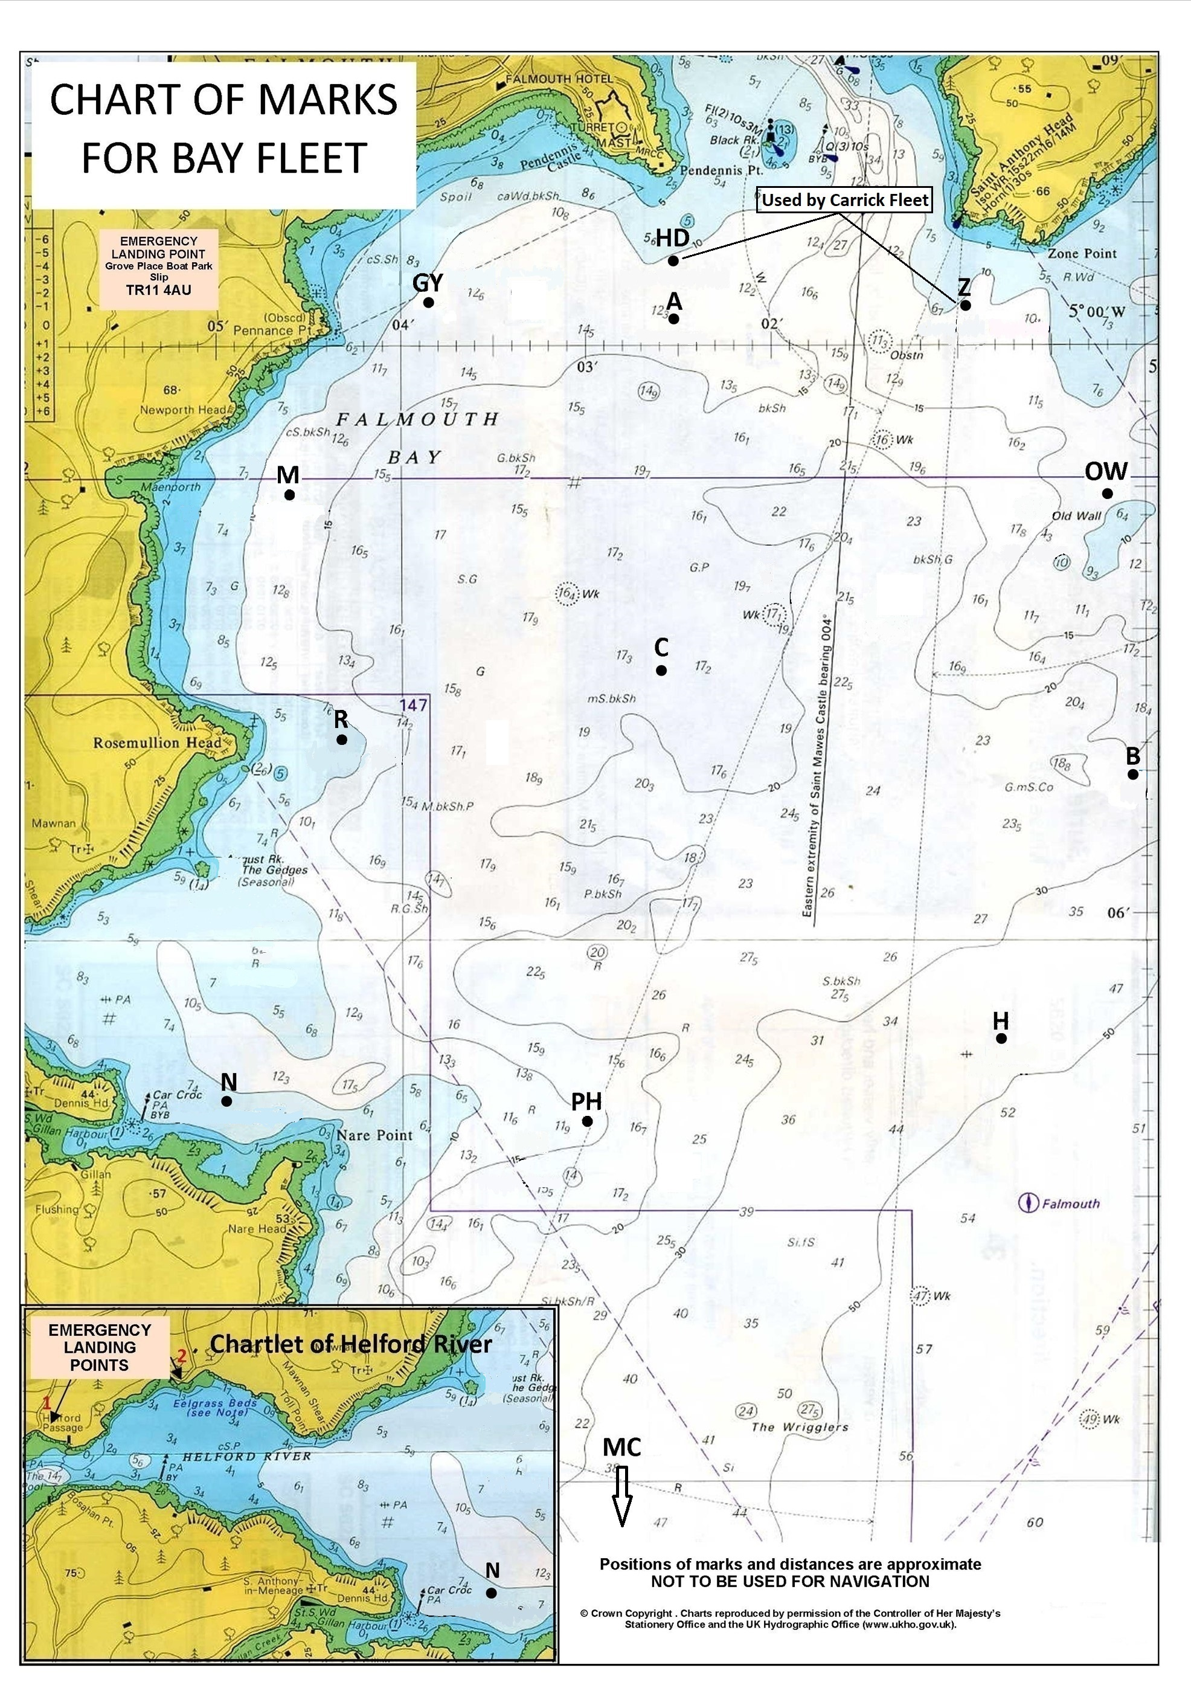

CHARTLET FOR THE ANCASTA CHAMPAGNE AND FIREBIRD LONG-DISTANCE RACES
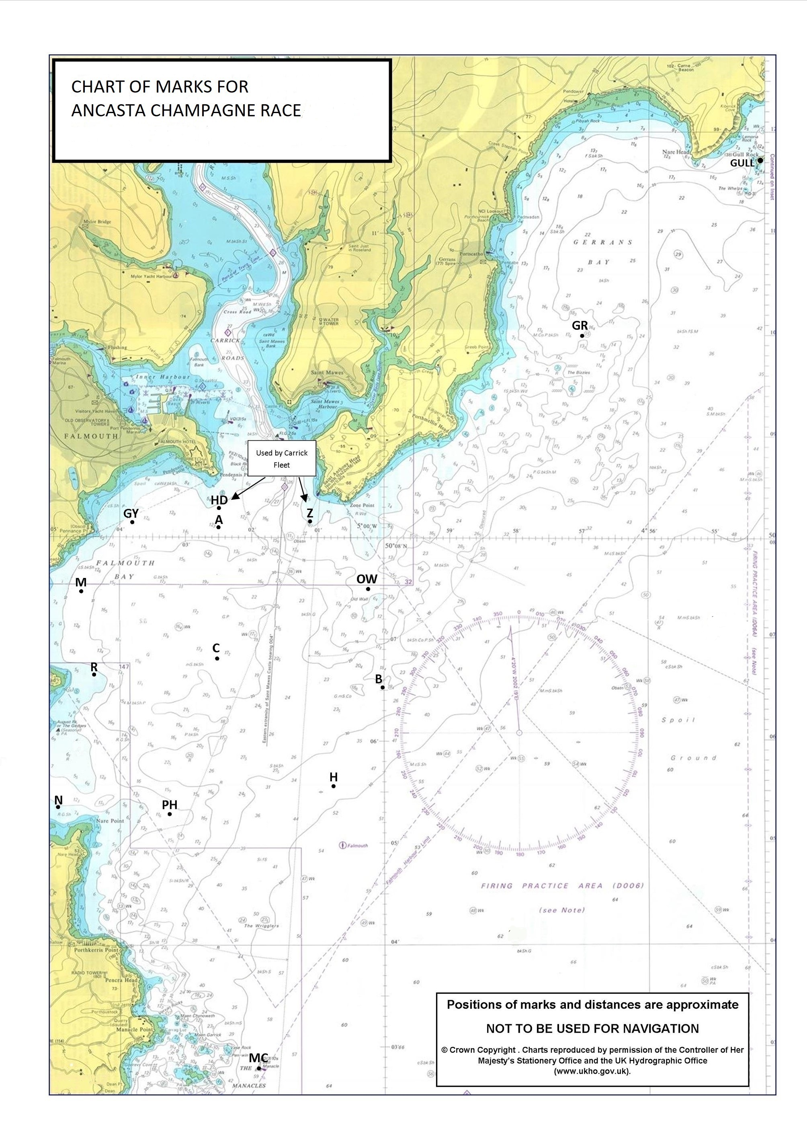

APPENDIX D: COURSES FOR THE ANCASTA CHAMPAGNE AND FIREBIRD LONG-DISTANCE RACES ON WEDNESDAY
The table shows the group of courses to be used for a given wind direction, and the courses in that group. All marks are to be passed to port unless otherwise shown; for example, R(s) means pass Romeo to starboard; PH means pass Papa Hotel to port.

FOR ALL GROUPS, COURSE 9 IS AT THE RACE OFFICER’S DISCRETION; SEQUENCE OF MARKS TO BE ANNOUNCED BY VHF.
GROUP 1 NORTH Start area: near mark C |  |  |  |  |  |  |  |  |  |  |  | Approx distance (nm)
1 | A | GY | MC | A | PH | H | OW | A |  |  | Finish | 23
2 | A | GY | MC | C | PH | H | A |  |  |  | Finish | 20
3 | A | GY | PH | H | A | GY | PH | C | A |  | Finish | 18
4 | A | GY | MC | B | OW | B | OW | A |  |  | Finish | 17
5 | A | GY | PH | C | A | GY | H | A |  |  | Finish | 16
6 | A | GY | MC | H | A |  |  |  |  |  | Finish | 14
7 | A | GY | N | PH | H | B | OW | A |  |  | Finish | 12
GROUP 2 NORTHWEST Start area: near mark C
1 | GY | MC | GR | PH(s) | N(s) | A |  |  |  |  | Finish | 27
2 | GY | H | GR | PH(s) | N(s) | A |  |  |  |  | Finish | 22
3 | GY | H | GR | C(s) | A |  |  |  |  |  | Finish | 17
4 | GY | MC | H | PH(s) | A |  |  |  |  |  | Finish | 15
5 | GY | MC | A |  |  |  |  |  |  |  | Finish | 13
6 | GY | PH | R(s) | H | A |  |  |  |  |  | Finish | 12
GROUP 3 WEST Start area: near mark OW
1 | M | MC | GULL | C(s) | A |  |  |  |  |  | Finish | 27
2 | M | MC | GR | C(s) | A |  |  |  |  |  | Finish | 22
3 | M | MC | H | PH(s) | B | C(s) | A |  |  |  | Finish | 17
4 | M | H(s) | PH(s) | B | C(s) | A |  |  |  |  | Finish | 14
5 | M | MC | H | C(s) | A |  |  |  |  |  | Finish | 15
6 | M | R(s) | N | H | C(s) | A |  |  |  |  | Finish | 12
GROUP 4 SOUTH WEST Start area: near mark C
1 | P | GULL(s) | H(s) | A |  |  |  |  |  |  | Finish | 23
2 | P | GULL(s) | OW(s) | A |  |  |  |  |  |  | Finish | 20
3 | P | H | GR | C(s) | R(s) | A |  |  |  |  | Finish | 18
4 | P | H | GR | C(s) | A |  |  |  |  |  | Finish | 16
5 | P | MC | H | C(s) | A |  |  |  |  |  | Finish | 13
6 | P | MC | H | R(s) | A |  |  |  |  |  | Finish | 13
7 | P | MC | OW | C(s) | A |  |  |  |  |  | Finish | 12
GROUP 5 SOUTH Start area: near mark GY
1 | MC | GULL | A |  |  |  |  |  |  |  | Finish | 23
2 | MC | GR | B(s) | A |  |  |  |  |  |  | Finish | 20
3 | MC | GR | A |  |  |  |  |  |  |  | Finish | 18
4 | PH | GR | OW(s) | A |  |  |  |  |  |  | Finish | 15
5 | PH | GY | PH | A |  |  |  |  |  |  | Finish | 14
6 | PH | C | PH | C | A |  |  |  |  |  | Finish | 12
7 | PH | H | C | H | A |  |  |  |  |  | Finish | 12
GROUP 6 SOUTH EAST Start area: near mark GY
1 | H(s) | R | MC | B | M | C | A |  |  |  | Finish | 22
2 | H(s) | R | MC | B | P | C | A |  |  |  | Finish | 21
3 | H(s) | R | PH | OW | N | C | A |  |  |  | Finish | 18
4 | H(s) | R | MC | C | A |  |  |  |  |  | Finish | 16
5 | H(s) | R | P | C | A |  |  |  |  |  | Finish | 12
continued on next page
GROUP 7 EAST Start area: near mark R
1 | OW | GULL(s) | MC(s) | A |  |  |  |  |  |  |  | 25
2 | OW | GULL(s) | H(s) | A |  |  |  |  |  |  |  | 20
3 | OW | GR(s) | MC(s) | A |  |  |  |  |  |  |  | 20
4 | OW | GY | N | B | M | R | A |  |  |  |  | 18
5 | OW | GR(s) | H(s) | A |  |  |  |  |  |  |  | 15
6 | OW | GY | R | OW | M | R | A |  |  |  |  | 15
7 | OW | GY | R | B | A |  |  |  |  |  |  | 13
GROUP 8 NORTH EAST Start area: near mark R
1 | GULL | MC | C | A |  |  |  |  |  |  | Finish | 23
2 | GR | MC | C | A |  |  |  |  |  |  | Finish | 21
3 | GULL | PH | C | A |  |  |  |  |  |  | Finish | 20
4 | GR | PH | C | A |  |  |  |  |  |  | Finish | 17
5 | GR | OW | A |  |  |  |  |  |  |  | Finish | 15
6 | GR | C | A |  |  |  |  |  |  |  | Finish | 14

APPENDIX E: TRAPEZOID COURSE DIAGRAM AND COURSES
- Course diagrams are not to scale and are indicative diagrams only.
- Marks 3s and 4s may not be laid. When only one gate mark is laid then boats shall round it to port.
- Internal angle: approximately 60°.
- Marks may be moved by not more than 200m and/or 15 degrees without signalling.

INNER COURSE DIAGRAM AND COURSES (not to scale; indicative diagram only)
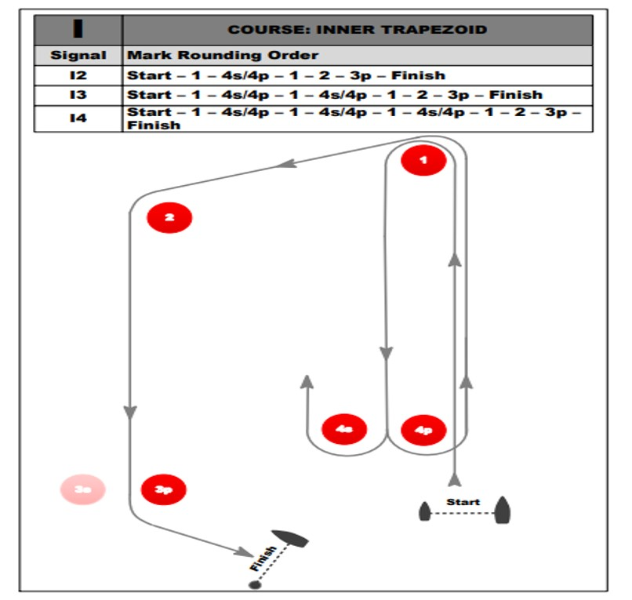

OUTER COURSE DIAGRAM AND COURSES (not to scale; indicative diagram only)

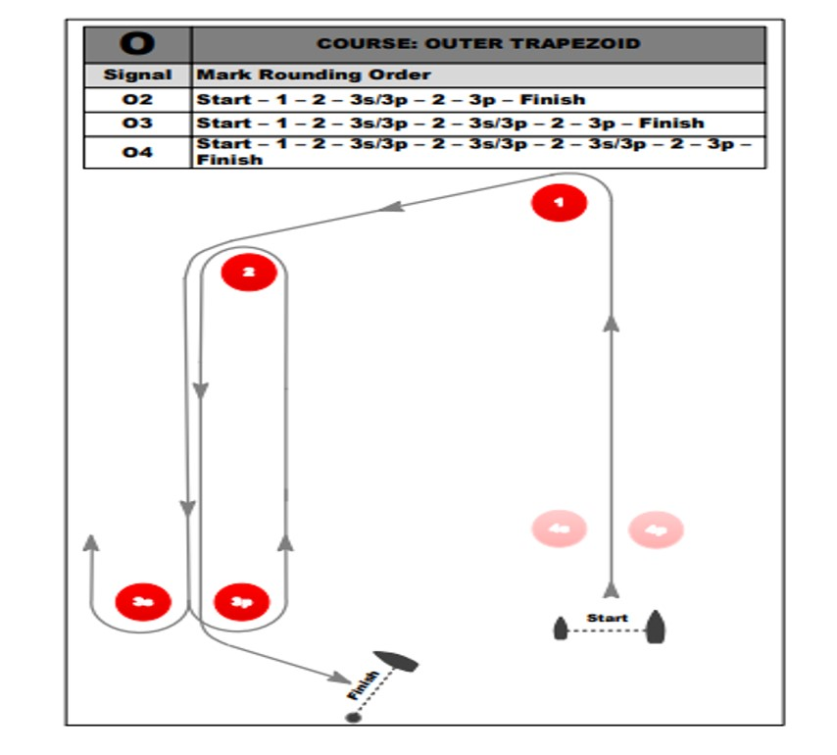

APPENDIX F: ROBOTIC SELF-POSITIONING MARKS
The start line and finish line outer limit marks, and the course marks of the trapezoid courses, will be MarkSetBot robotic self-positioning marks.
In addition, a MarkSetBot will be laid as the finish line outer limit mark, and may be laid as the first windward mark, and other marks, of a regatta course.
An example of a MarkSetBot is shown in the picture below. The marks may display sponsor’s advertising and may be a different colour to the picture.

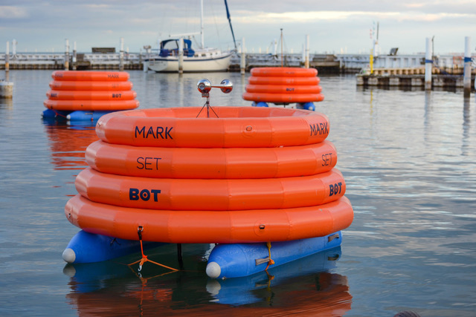

Mark sponsors are:
- Savills
- Marlow Ropes
- Athrosomaid by Contuta

*******************************************
NOT PART OF THE SAILING INSTRUCTIONS
*******************************************
QR CODE TO JOIN THE BAY FLEET WHATSAPP GROUP

- Open WhatsApp, tap Camera
- Hold device over the QR code to scan (adjust distance so QR code fits the screen)
- Tap ADD



